Eurospanbookstore.com user manual


Contents
Introduction 3
How does it work? 3
Starting buying a book 3
Step 1 Search for the book you need 3
Step 2 Make your order 5
Step 3 Create an Account 6
3.1. Billing information 6
3.2. Shipping information 7
3.3. Shipping method 7
4. Payment information 8
5. Order review 9
Done! 9
For information: 10

Introduction
Eurospanbookstore.com is an online book store by Eurospan group, where you can buy a book online and it will be delivered to you.
More information about Eurospan group - http://eurospangroup.com/about-us/

How does it work?
In general, online shopping has three major steps outlined simply as find what you want, enter in your address and other information, and make the purchase.
When you have found what you are looking for you add that item to your virtual shopping cart by clicking the tag ‘add to cart’. The virtual shopping cart acts like a real shopping cart in which you can put anything you want. You continue adding items in your cart when you have finished shopping. Ultimately, you click on the icon “check out” then enter in your address and credit card information. After that, the items you purchased are then shipped to you.

Starting buying a book
Please visit http://www.eurospanbookstore.com/

Step 1 Search for the book you need
Use the search box to find a particular book by the title, author, ISBN or keywords.
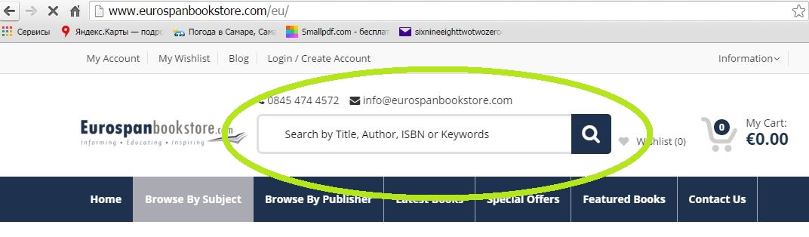
Or go to the Bestsellers section to see the top rated ones.
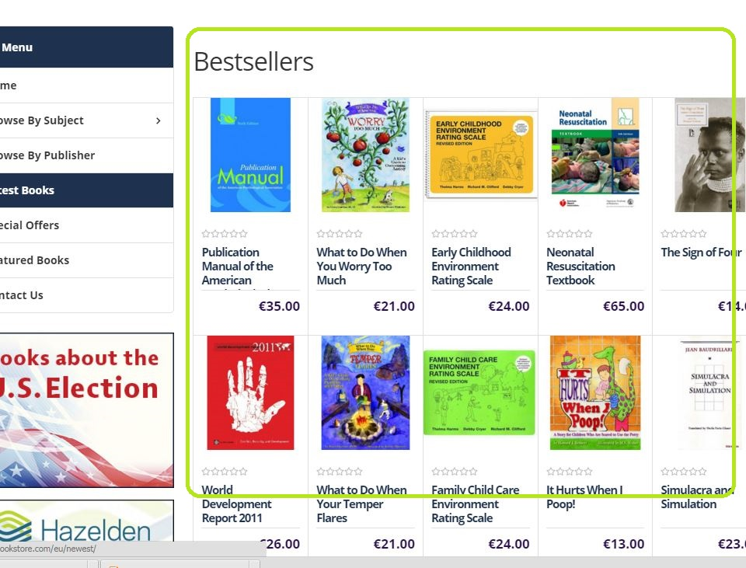

Also you can use the “Browse by subject” tool to choose a particular category in the drop-down menu. It’s one of the options in the left navigation menu which can help you to refine your search by such criteria as Latest Books, Browse by Publisher etc.
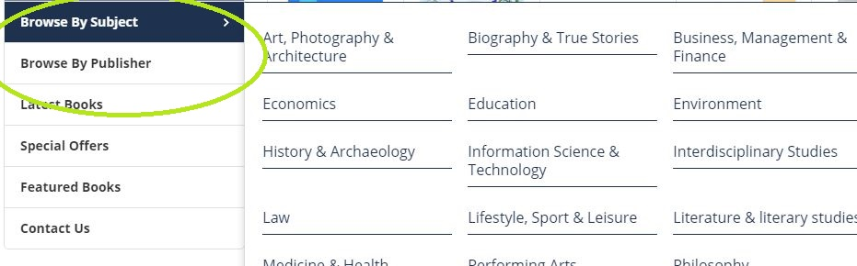
The search results will be displayed as a list of items with quick view information, containing the price, author and the cover picture.

Step 2 Make your order
Once you find what you need, click on it and proceed to the book’s review. Here you can find the full information including the price.
Manage the quantity by clicking “+” and “– ” tool right under the price.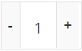
Start your purchase with clicking “Add to Cart”. With the pop out window you’ll be asked whether to Continue Shopping – you can browse more books and choose something else to buy (by adding more items in your Cart), or Go to Cart and finish the order.
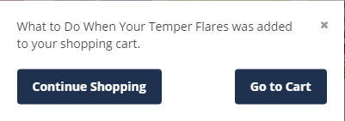

When you entered your Shopping Cart you can edit your order by the “Edit parameters” and “Remove item” tools. For example, you added three books searching through the categories. Then, in the Cart, you can delete some and remain just one.
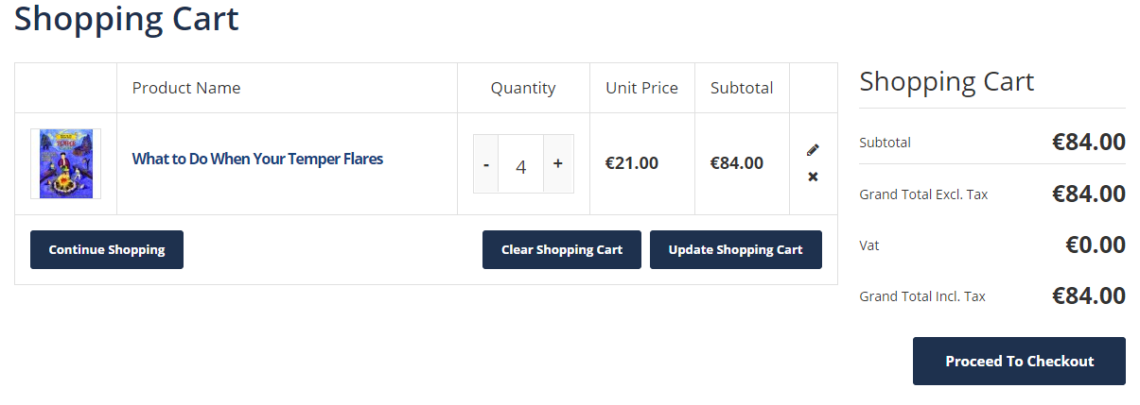
Also you can see here your order total price.
To finish you order click on button.

Step 3 Create an Account
If it’s your first purchase on Eurospan book store, you’ll be asked to register an account. 
The registration process is quite general.
Note: You can do it by clicking “Login/Create Account” on the main page,
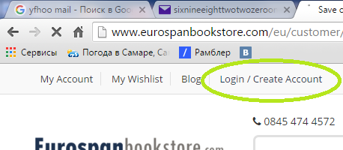
Or while your fist order. In both you’ll get a confirmation letter on your email. Let’s see the second variant since we are on this step.

3.1. Billing information
Enter you name, email address, make up a password and then click on Submit button .
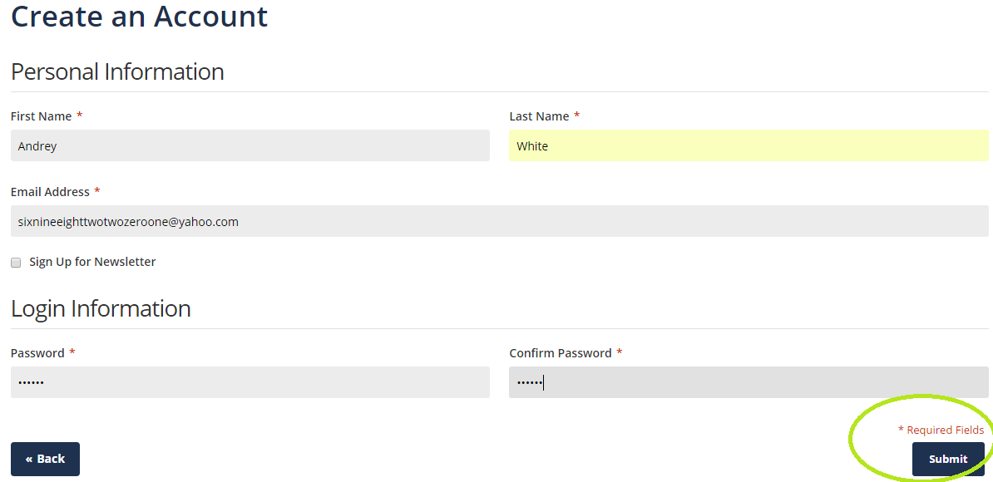

3.2. Shipping information
In the next step enter your shipping address where the books you buy here will be delivered at. 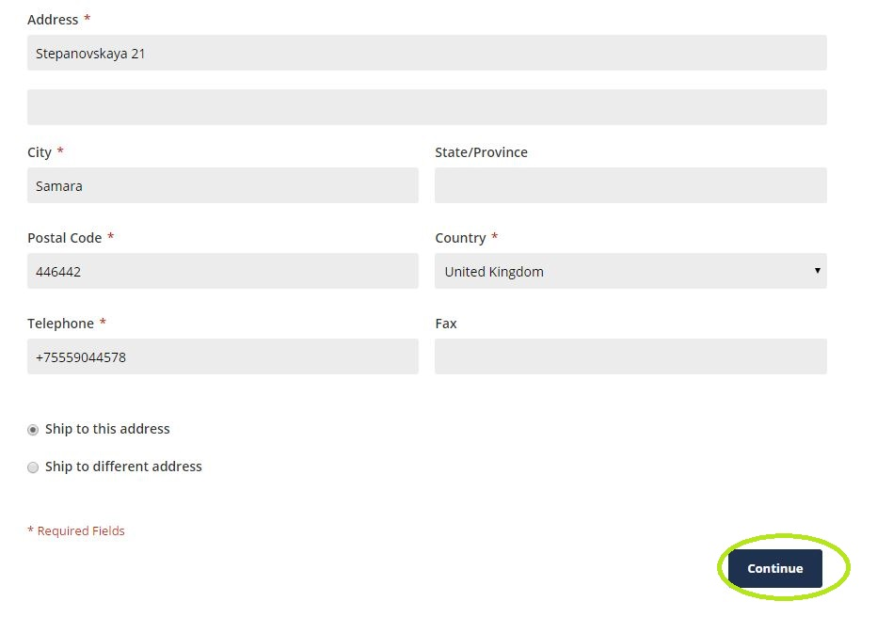
Click on Continue button.
Note: In case of sending your order to address, you will have such option.
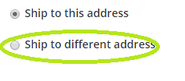

3.3. Shipping method
Here you can choose between free standard mail service and worldwide airmail (extra price).
Tick it off.

4. Payment information
Here you are supposed to choose payment method. Our choice is Secure Card Payment.
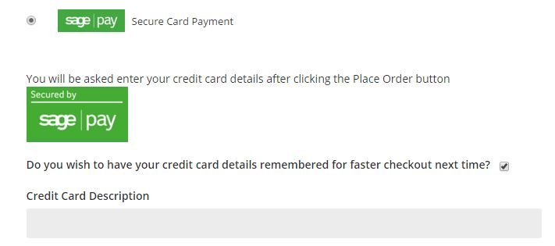
Note: The “Purchase order” option is related to Universities, Local Authorities and other public institutions.
To continue, the pop up window will ask you to enter your credit details.
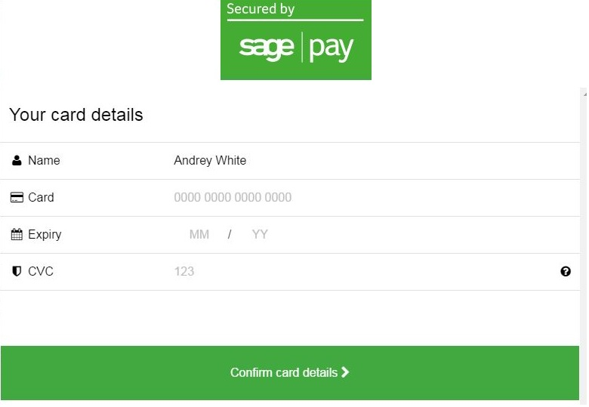

Click on “Confirm card details”

5. Order review
Finally you can review your order with all options chosen and then finish it by clicking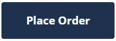.

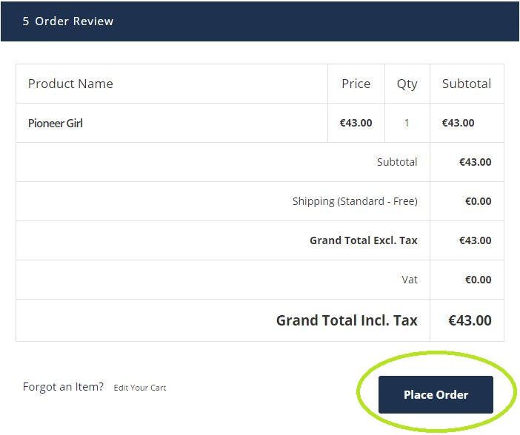

Done!
You will see a confirmation message with your order number.
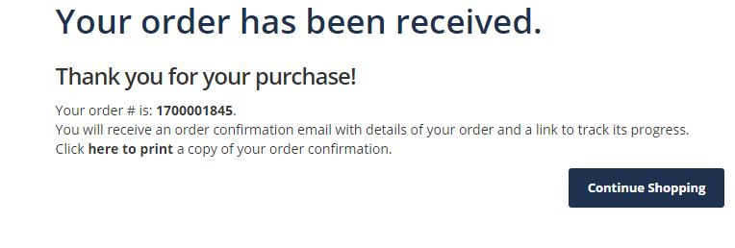
Also you will be informed about successful ordering by email.
The order is placed. Soon you’ll get a parcel!

For information:
Speaking about order tracking, standard free shipping is sent by regular parcel post and is not tracked. There is an option to select expedited shipping which is calculated at the checkout based on weight and country, this service is trackable and the shop provides tracking details.
For further purchases just login by entering your email address and password and then clicking Login button
